*High Level Design –* ***Aspire***

***Overflow***

**Document ID: Author(s):** Aurora

**Version:** 0.1

**Date:** April 18,2022

**Table of Contents**

Shape

1. Introduction
2. Non-Functional Requirements
3. System Architecture
4. Data Model
5. Database Diagram
6. Services

**Introduction**

This document provides a detailed design of the system. It starts with the design principle used, list the non-functional requirements and a detail description about the subsystem or components which comprise the system and their interactions.

**Non-Functional Requirements**

**Security:**

Our system allows user to access the platform only after the verification from admin side so our sensitive article contents maintain only within users we allowed to access.

**Compatibility:**

Our system supports all web browsers and all type of devices.

**Maintainability and Manageability:**

Aspire Overflow follow all the standard principles of design so it is easy and manageable in case any problem occurs.

**Usability:**

We build our platform simple and easy to use for every user.

**System Architecture**

**Data Model**

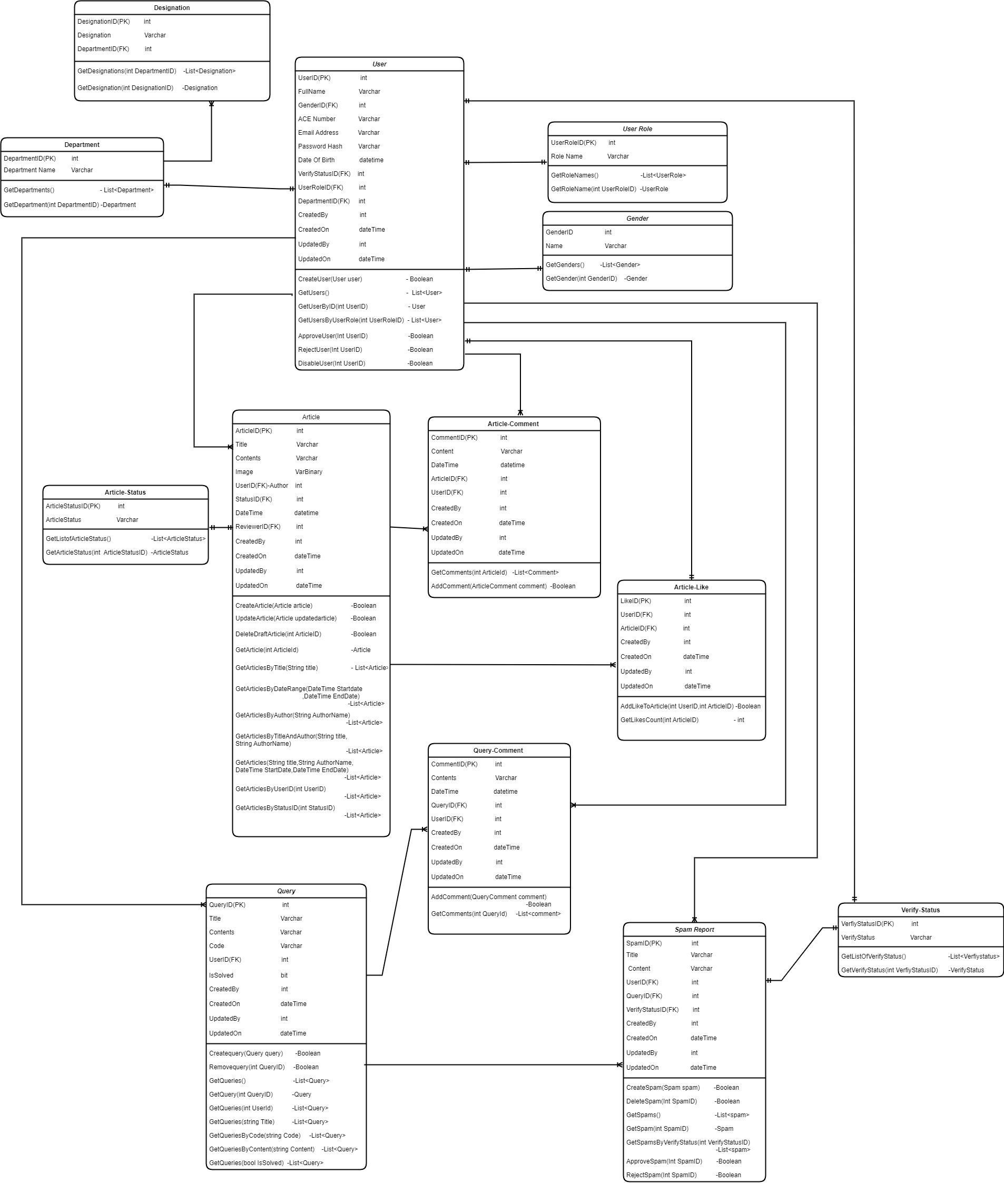

**Database Diagram**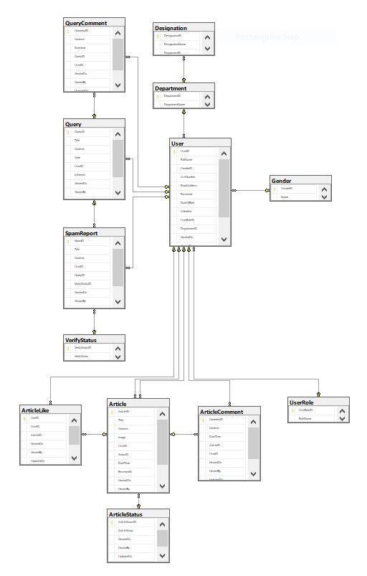

**Services**

